**Lab 2: Mapping the Money**

*Geog2011: Introduction to GIScience*

**Introduction**

Mapping census and other demographic data is a very common task in spatial analysis. In this lab, you’ll be looking at data on household incomes to analyze both a community you’ve lived in and the Atlanta metro area. You will download these data from the National Historic GIS (NHGIS) service. This is a chance to learn how to work with a data resource that contains public Census data. Through this you’ll gain experience using descriptive statistics, joining non-spatial data (.csv) to spatial data (.shp), and working with QGIS to map spatial data.

**Preparation: Software, county data, and NHGIS registration**

In this lab, we’ll be working with the open source desktop software QGIS to map spatial data. If you’re not on a computer with QGIS already installed, you’ll need to download and install it before beginning. Here’s a link to the download:

<https://www.qgis.org/en/site/forusers/download.html>

You want the standalone installer for whatever is the latest **long term release** for your operating system. QGIS is open source software, meaning that it was developed by a voluntary group of programmers, with source code visible to the general public ([on GitHub](https://github.com/qgis/QGIS)), and is distributed completely free of charge.

You will also create an NHGIS account (we’ll cover those steps in a bit). You also need a spreadsheet program. Microsoft Excel is on the campus computers, but there are multiple other options: Google Sheets, Apple Numbers, or OpenOffice Calc.

There’s two data files to download from ELC:

* USstates.zip: Zipped shapefile of U.S. state boundaries
* geog2011_locations_sum21: geojson (vector) file with the residential location data we created about ourselves in class

Next, you need to create an NHGIS account. This is a free service, and is one of the best ways to access GIS friendly census data going all the way back to 1790. We will do this in class, but if you missed it, you can register at [this link](https://uma.pop.umn.edu/nhgis/user/new?return_url=https%3A%2F%2Fdata2.nhgis.org%2Fmain).

This lab will walk you through the following steps:

* Download income data and census boundaries from NHGIS
* Prepare the income data in Excel (or another spreadsheet)
* Load the boundaries and income data into QGIS
* Join the data and visualize it using a choropleth map
* Load our location data and query the income layer
* Adding state boundaries and styling the data
* Create a print map of your data for the lower 48 states.

**Downloading Census data**

First, you’ll need to download data on household income. Go to [the NHGIS page](https://www.nhgis.org/), register if need be, and then log in. Click on “Select Data” on the left hand side. Set up the following filters for your data search, using the buttons near the top of the page:

* Geographic Levels: Tract
* Years: 2014-2018 (under “Five year ranges”)
* Topics: Household and Family Income (under the “INCOME” heading)

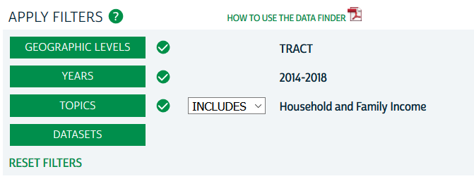

A list of matching datasets now appear at the bottom of the page. Click on the green plus sign next to table **B19001 Household Income in the Past 12 Months (in 2018 Inflation-Adjusted Dollars).**

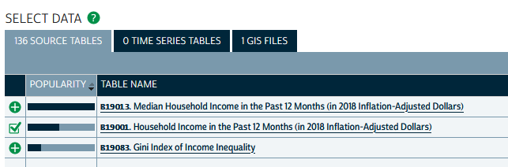

You’ll notice that there’s also an option for ‘1 GIS Files’. These are corresponding tract boundary shapefiles. We will provide those to you, but you could click on this if you wanted the boundary file.

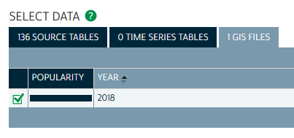

In the upper right hand corner of the page, you should see 1 source table in the Data Cart. Click the green “Continue” button in that Data Cart box.

This page just lists the tables you’ve selected. Click ‘Continue’ again. The next page clarifies the format you’d like to have for your data. The default settings here are fine. Click on “Submit” at the bottom of the page.

It can take five minutes (but probably less) for the system to retrieve your data. You can either keep refreshing the page or check your email for a notification that the data are ready. Download the table by clicking “tables,” which will give you a single zip (compressed) folder with a spreadsheet and text metadata file. Move these to the lab folder on your flash drive or personal machine. You should also extract them from the zipped folder. The easiest way to do this is to double click on the folder to open it and then drag the contents to your working folder.

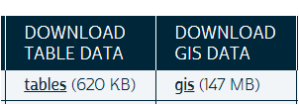

**Examining the tables**

Let’s take a look at these data. Start by opening the codebook text file from the table folder. Scroll down to the bottom. You’ll see a list of variable codes and names, looking like this:

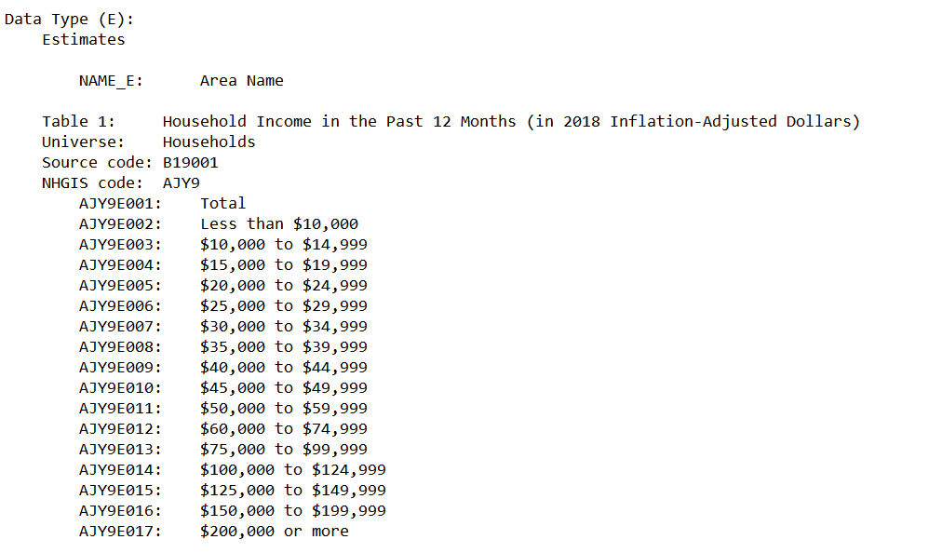

This codebook is the metadata. You will see the ‘NHGIS code’ starts with ‘AJY9Exxx’ as well as a name for each variable. There is also a variable named ‘GISJOIN’, which is the field that we’ll use to join these data to our shapefile in QGIS later in the lab. Also notice that there’s fields for both the actual population estimates (“AJY9Exxx”) and margins of error (“AJY9Mxxx”) in these data.

For this assignment, you’ll be analyzing the rate of upper income households, those exceeding $100,000 per year. You’ll have to combine counts from four variables to do this--$100K-$124K, $125K-149K, etc. Look through the metadata and identify the relevant variable codes.

**Preparing the data for analysis**

Now we need to create a variable showing upper income households as a percentage of all households. Open the spreadsheet (.csv). You’ll see a long sequence of columns with information on the county. Beginning in column AL you’ll see the variable codes listed above. You can delete any empty columns, then save the csv file.

Note that the data provided here are ***count*** data--the numbers of people in each category by tract. We’re not interested in tracts with no population, so you need to delete those. Sort by the =total population column (variable AJY9E001). Select and delete rows with 0 or that are blank for total population. If you sort the column from lowest to highest, there will be the top and bottom rows.

Now you can create your rate variable. Find the four columns with the variables you want. Create a new variable using a column at the end of the data, which you can call “inc100” (or any other name you think is good). Use a formula to sum the values for each of the four columns you identified. Then create a second column that divides this count by the total population variable (AJY9E001) so that you have the percentage of all households.

* [Link to a video](https://youtu.be/TNvGMWENllk) that walks through this process for low-income households (different variables from the lab)

Save the file when you’re done.

**Loading the spatial data**

Now you’re ready to load these data into QGIS. Open the program and load the U.S. tract geopackage file you downloaded from ELC and your CSV file. To do so, use Layer > Add Layer and then vector (for the geopackage) or delimited file (for the csv). The CSV file isn’t spatial, so you’ll need to select “No geometry” under Geometry definition as shown below.

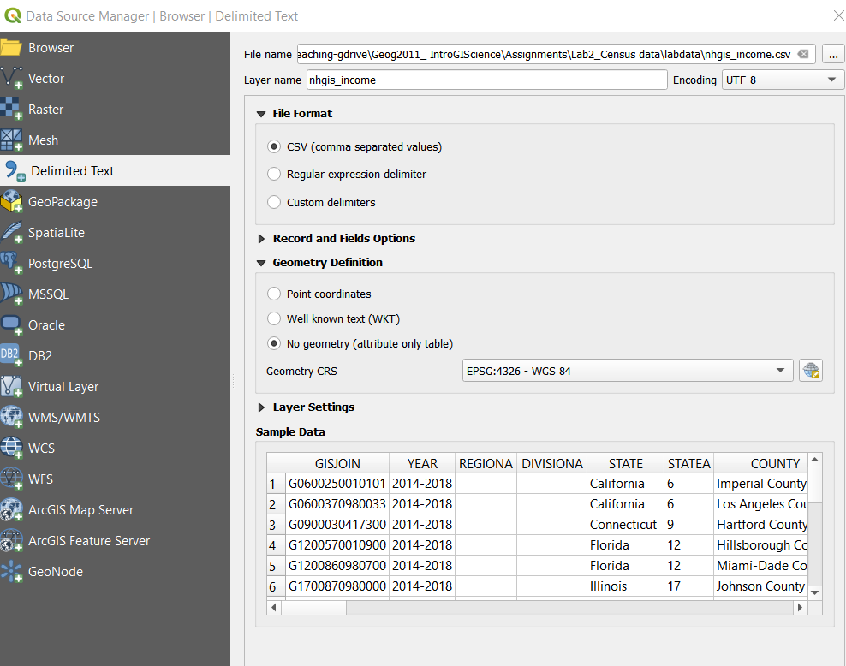

Occasionally you may encounter the problem that a numeric column (such as % of the population below an income threshold) is read in as a string/character column. When that happens, you won’t be able to symbolize it as a numeric variable later on in this process. Here’s a link to a short video showing strategies to fix it if it happens to you:

* [Converting character columns to numeric](https://youtu.be/RIKg7xubxbE)

Additionall, if you’re using the online version of Excel, that only exports data in xlsx (Excel) format. You can use the Spreadsheet Layers plugin to import that file--here’s a short video walkthrough:

* [Using the Spreadsheet Layers plugin to import Excel files to QGIS](https://youtu.be/KWWQnYy7VYA)

**Joining and visualizing the data**

Once you’ve loaded both layers, right click on the tract layer in the Layers window and choose “Open Attribute Table.” This will show you a list of included variables in this boundary file. There’s not that many at this point.

To connect the income data to this tract file, you’ll need to *join* the CSV to the spatial data, which means connecting them based on a shared id variable that’s unique to each county. In this case, NHGIS provides a GISJOIN variable that’s based on [the county FIPS code](https://support.esri.com/en/technical-article/000002594).

Here’s a couple of resources that can help you figure out how to do this join:

* [A guide to joins in QGIS](https://guides.library.duke.edu/QGIS/Joins) from Duke’s library
* [A video walk through](https://youtu.be/uhlJ-LlYmcM) of joining data on YouTube, in this case working with county employment data.

Once you’ve joined the data, the tract layer’s attribute table should show the additional variables. Now you can create a choropleth map (graduated colors) for the rate variable you created. You can do this by right clicking on the tracts layer, choosing Symbology, and selecting the variable and classification scheme you want to use. This video walks through the general process using a different dataset--see the section that starts at about the four minute mark.

* [Link to the video](https://youtu.be/J19-AszzaB4)

Choose a color and classification scheme that you think is appropriate for the data. You’ll have to justify your choice in the lab document.

**Adding location data**

Before we add the location data, you’ll need to make sure the projection for the map is Albers Equal Area Conic. In the lower right hand corner of the window, you should see the Projection tool for the dataframe, which looks like this:

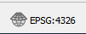

In this case, it is WGS 84, which has an [EPSG](http://www.epsg-registry.org/) number of 4326. If this is the case for you, you’ll need to select a different projection. For the USA Albers map, you can type its EPSG number (102003) into the filter box and it should show up in the list at the middle of the page. Select it and click OK. Don’t worry if your map disappeared after changing the projection. After changing the dataframes’s projection, we also need to change the layer’s projection. Right click the tract layer, go to Export -> Save Feature As, choose “geopackage” from the format drop-down menu, specify file name, and change the CRS to the same projection of the dataframe (USA Albers Equal Area Conic). Once the exporting process is finished, the new layer will be added to the project.

You should now see the familiar map of the US with a smile shaped northern border.

Next you should add the ***class data on our residential locations***. That’s available in the geojson file you downloaded. To add this to QGIS, open the Add Layer tool again and choose the location file as a vector.

You’re free to use the default display options, but note that you can also change the color and size of these points under the same Symbology tab in Properties that you used to make the choropleth map.

**Querying the income layer**

For your lab response, we’re asking you to identify the rate of high income households for one of the points in our class data, preferably one of the places you’ve lived. To do so, you’ll need to zoom to this point. You can use a mouse and scroll wheel to do so, or use the Zoom tool to draw a box around the point--it’s in the top toolbar and looks like this:

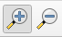

Once you’ve zoomed into your point, make sure the tract layer is selected in the Layers window--the one in the lower left. You can then use the Identify Features tool to pull up information on the tract containing your point. It’s also in the toolbar and looks like this:

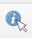

Once it’s selected, click on the tract you want information on, and its attribute table information should show up in the lower right.

**Styling the map**

To make this map easier to read, we’re also going to add state boundaries. Load the USstates shapefile. To style this map, you need to make the fill of each state transparent, while keeping the boundaries. In the Style window (under Properties), click on the “Simple fill” box at the top. You’ll see a list of properties in the middle of the window. Click on the dropdown arrow on the right hand side of ‘Fill’. Click on the “Transparent fill” box. Then scroll down and set the outline width to .5. This will thicken the borders of the states.

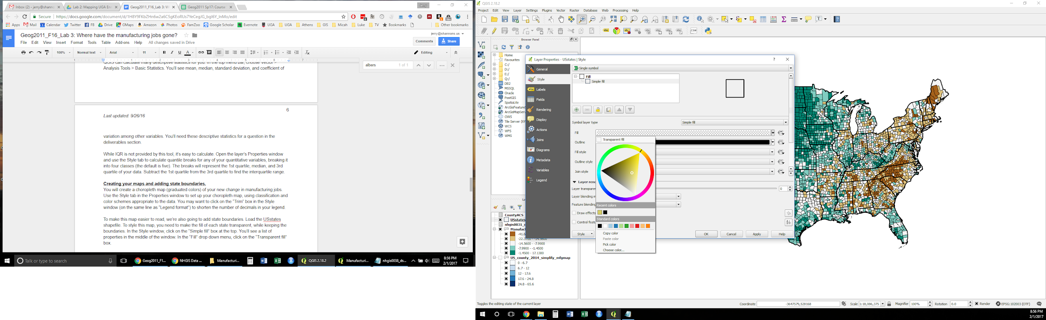

Census tracts are very small in urban areas, which means that at a national level, their boundaries make the data hard to see. Fortunately, we can make these boundaries transparent. Open the Properties window for the tract data and go to the Symbology tab. Click on the box next to Symbol that says “Change.” You can make boundaries transparent in the window that opens up. Here’s a GIF that shows the process:



Your map should show the tracts (but not their borders) as well as the state boundaries.

**Map layout**

You will use print composer to create a print version of this map for the lower 48 states. I’ve created [a video walk through here](https://youtu.be/nVdtVMeHAP4) looking at employment in the arts and hospitality industries, and you can also look at the [QGIS documentation](https://docs.qgis.org/testing/en/docs/training_manual/map_composer/map_composer.html) to figure it out.

Your map should contain these required map elements, in addition to the map itself.

* Title: “Rate of high income households: U.S. Census Tracts”
* Legend
* Scale bar
* Citation: “Data from U.S. Census and NHGIS”

In your layout, make sure the map is zoomed to just the 48 lower states. Also make sure the map is front and center, with the other elements placed suitably around it. The scale bar, citation, and legend are usually in lower corners, for example, with the legend more prominently placed in an open area. Save the map as a jpeg image.

**Video summary**

Your submission for this lab will include a video component as well as written responses and your print map. There a few main reasons why we’re asking you to do this. First, explaining how you created these maps through video pushes you to use higher level spatial thinking. You’re not just getting the right answer or following instructions, but having to explain what you did in your own words. Second, video allows you to be more interactive and specific in discussing your maps. You can zoom or move the mouse to specific areas of the map as you discuss it. Third, these videos focus us on the big picture story your maps have to tell rather than on the just specific data points and details.

Using whatever tool seems best to you, your job is to create a video summarizing the analysis and findings of this lab to someone unfamiliar with it. You can do this as a screencast--just showing both of your maps on screen as you talk over them, also including your face using the computer camera if you want to.

There’s a couple of software tools you can use to create screencasts:

* [Screencast-O-Matic](https://screencast-o-matic.com) provides tools for doing screencasts via the web or through their desktop software.
* UGA has a subscription to the video archiving tool Kaltura and allows you to capture and/or upload video using that tool. [Here’s a link to instructions](https://help.elc.uga.edu/students/video/). Kaltura is integrated with ELC.
* Apple users can also record screencasts using the built in screen capture tool. [Here’s instructions](https://support.apple.com/en-us/HT208721) for doing so.

Your video should do three things:

* Give a brief summary of what the map shows and where the data came from. (2 points)
* Summarise one other geographic trend you see on this map--either nationally or at some smaller scale (state, metro area, etc.). This can include the location of our class points if you wish--how our residential histories correlate with income. Be specific in describing this trend, using the Identify tool if needed to provide specific figures. (5 points)
* Zoom to one of the points in our class data and identify the rate of high income households for its census tract (3 points)

These videos should be around 2 minutes in length (and no more than 3). You can submit them by uploading to Kaltura or YouTube and then adding a link to the final video in the Comments section of your submission

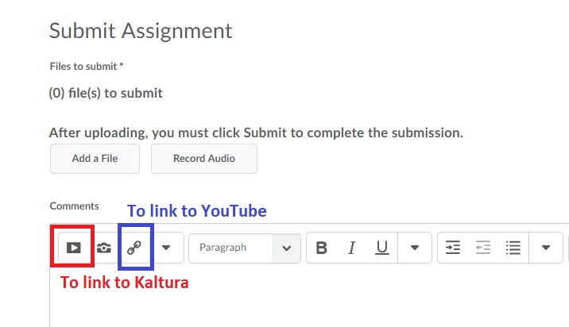

If you don’t have a computer capable of recording video, let us know and we can work out alternative arrangements.

**Lab deliverables**

Your final print map should contain all required elements and use a color and classification scheme that fit the data. Make sure your map includes tracts (with boundaries de-emphasized as shown in the video tutorial) and states (with boundaries only). It should also be zoomed to just the 48 continental states.

You should submit a written document with a short explanation of your map design choices (see below) and the map you created.

* Your map will receive up to **20 points** depending on how closely it matches the required specifications.
* Your written response should give a justification for the classification and color schemes used on your choropleth map, referring to either the Manson text or class lecture. You’ll receive up to **10 points** for this response.
* Your video will receive up to an additional **20 points** based on your video response as noted above.

We look forward to hearing about what you find!